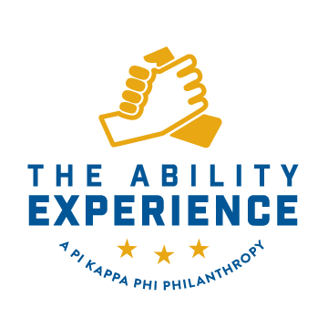
Job Description
Updated 3.27.2019

Position title: Associate Development Officer

Reports to: Assistant Executive Director of Development and Engagement

General description:
The Associate Development Officer will direct and execute The Ability Experience giving strategy. Specifically, the Associate Development Officer will direct and execute the plan to strengthen The Ability Experience mid-level giving program through face-to-face cultivation, solicitation and stewardship in major markets across the United States.

Qualifications:
Individual must have strong written and verbal communications skills. Individual must be detail-oriented and have the ability to travel and work independently to execute the organization’s giving initiatives. Proficiency in donor software database required. Must be a leader as well as a team player, and have ability to work cooperatively with other development staff.

Education/Experience:
Bachelor's degree. Experience in management and fund-raising preferred.

Supervisory responsibility:
Supervises Interns.

Duties and responsibilities:

The Associate Development Officer will take the initiative to secure gifts by implementing fundraising methodology as follows:

- Appointment Setting. Schedule appointments with prospects of The Ability Experience through telephone and e-mail outreach for pre-arranged appointments.
- Case Statement Presentation. Explain the Case for Support (reasons to give) in a concise and compelling manner to raise donor awareness and enthusiasm.
- Gift Solicitation & Follow-Up. Present giving options; overcome objections and pursue gift commitments during and after the face-to-face appointment.

The Associate Development Officer will also show leadership by:

- Adhering to the program’s performance metrics and will be held accountable for such, weekly.
- Displaying a willingness to learn and share new ideas in a collaborative environment.

Qualified candidates must also demonstrate:

- Superior written and verbal communication skills, as well as strong presentation and liaison skills.
- Strong organizational skills.
- Ability to represent The Ability Experience and Pi Kappa Phi in a positive and professional manner during interaction with constituents.
- Computer literacy, including strong understanding of Microsoft Word, Microsoft Excel, Microsoft PowerPoint, and web conferencing, as well as other database and web-based fundraising tools.
- Ability to work well independently while maintaining strong communication with The Ability Experience executive office in Charlotte, NC
- High level of integrity in dealing with confidential information.
- Capacity to deal comfortably and sensitively with high-level donors.
- Ability to forge strong working relationships with others and a capacity for engaging trust among donors.
- Understanding of and commitment to healthcare and the mission of Pi Kappa Phi and The Ability Experience.

