March Mayhem 2020

March Mayhem returns for Spring 2020! The bracket style online fundraising competition between ALL Pi Kappa Phi chapters is promised to be bigger and more competitive this year.
The tournament concept is simple: The top 16 chapters from each region with the most online donations during the qualifying period will move on and be seeded into the bracket stage (see region map below). Each round, chapters will go head to head competing against each other with the fundraising dollars resetting at the end of each week, so chapters need to be strategic. The chapter with the most raised online each round will move on. While the bracket tournament winner is the grand prize, there are multiple prizes up for grabs!
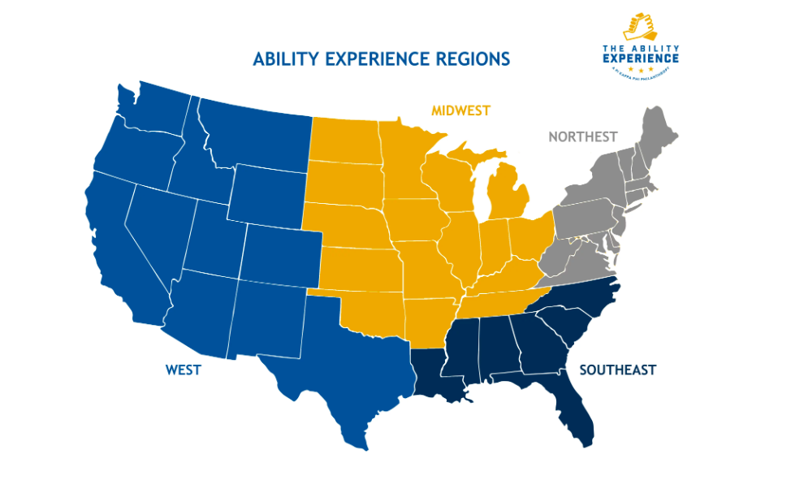
March Mayhem Rules
This is a bracket style online fundraising completion where chapters face off against each other in a tournament. Each round mirrors the dates of the NCAA College Basketball Tournament.
- Chapters are seeded for round 1 based on dollars raised in the qualifying round. Minimum of $1 raised in order to qualify. However, only the top 64 chapters will advance to round 1 (16 per region).
- Chapters start each round fresh at $0 (funds will not reset on Classy, but leaderboard will be updated).
- All fundraising must be submitted online, ACH transfers, OmegaFi and checks will not count towards March Mayhem fundraising.
- Event fundraising is only accepted for events that occur during the designated round and incorporate peer to peer fundraising.
- Donations for each round must be submitted before midnight (CST) on the final day of that round.
- If eliminated from the bracket tournament, chapters and individuals are still eligible for prizes (listed below).
Prizes
Tournament Champion:
- Pi Kappa Phi Customized Corn Hole Boards or Tailgate Tent or Ability Experience Tabling package
- Free Ability Camp registration for chapter (up to 50 men)
- Basketball Display Case with ball signed by The Ability Experience CEO, Basil Lyberg, and Pi Kappa Phi CEO, Mark E. Timmes
Final Four Chapters: Regional Champion Trophies
Sweet Sixteen Chapters: Sweet Sixteen Trophies
Elite Eight Chapters: Elite Eight Trophies
Highest Fundraising Chapter*: Recruitment Swag Pack
Conference Champions: New this year, raise the most among chapters in your school’s conference and win a conference championship! Eligible Conferences (based on number of active chapters in each): ACC, American, Big 10, Big 12, Conference USA, MAC, PAC 12, SEC, SoConn and SunBelt.
*Highest Fundraising Chapter does not include the tournament champion. Chapters that did not qualify for the tournament can compete for this prize.

March Mayhem Schedule
- (March 16-19) Qualifying Round- The top 16 chapters from each region who participate will be ranked from highest to lowest and placed in a bracket.
- (March 20) Selection Monday – Bracket Announced
- (March 20-22) Round 1 – Winning team advances in the bracket.
- March 23-25) Round 2 – Winning team advances in the bracket.
- (March 26-28) Round 3 – Sweet Sixteen - Winning team advances in the bracket.
- (March 29-31) Round 4 – Elite Eight - Winning team advances in the bracket.
- (April 1-3) Round 5 – Final Four - Winning team advances to Championship Round.
- (April 4-7) Championship Round – A Champion is crowned

