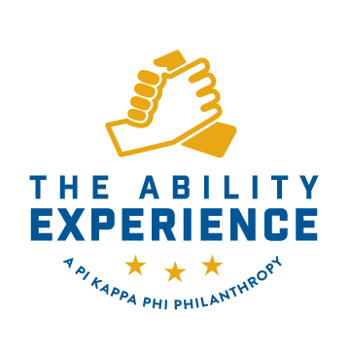
Philanthropy Fundraising Plan 2022

In order to help your chapter succeed and continue growing your philanthropy program, I need you to fill this document out to the best of your ability. Once you have completed it send it back to jlogar@abilityexperience.org

This is what needs to be included under each month:
- Fundraising: Event Name, Tentative Date, Projected Fundraising
- Awareness: Event Name, Tentative Date
- Volunteering: Event Planned, Tentative Date

As you fill this out keep in mind the 2022 Fundraising Goal that you have set for yourself. Remember that you do not need to do a big event each month. A percentage night or an email campaign can go a long way. We will be discussing this document going forward on each of your calls.

Name:
Chapter:
2022 Service Hour Goal (Tentative):
2022 Fundraising Goal:

Examples: Email Campaign for March Madness, Basketball tournament, Phone a thon, Letter campaign, host a benefit night a restaurant on campus, use social media to encourage donations, Pie a Pi Kapp, Bike a thon, War of the Roses, Pi Kappa Fries, Email Campaign, Social Media Bingo Squares, Video Game Tournament

Spring Semester
January
- Fundraising:
- Volunteering:
- Awareness:

February
- Fundraising:
- Volunteering:
- Awareness:

March (March Mayhem)
- Fundraising:
- Volunteering:
- Awareness:

April
- Fundraising:
- Volunteering:
- Awareness:

Summer
May
- Fundraising:
- Volunteering:
- Awareness:

June
- Fundraising:
- Volunteering:
- Awareness:

July
- Fundraising:
- Volunteering:
- Awareness:

August
- Fundraising:
- Volunteering:
- Awareness:

Fall
September
- Fundraising:
- Volunteering:
- Awareness:

October (Fall Break)
- Fundraising:
- Volunteering:
- Awareness:

November (Thanksgiving Break and Beardsgiving)
- Fundraising:
- Volunteering:
- Awareness:

December (Winter Break)
- Fundraising:
- Volunteering:
- Awareness:

